Assignment 06  
  
**Movie Ticket Management System - Hello World Spring Boot Web Application**

**Step 1: Create Spring Boot Project Using Spring Initializer**

**Go to:** [**https://start.spring.io**](https://start.spring.io) **Select the following options:**

* **Project: Maven**
* **Language: Java**
* **Spring Boot: Latest stable version**
* **Group: com.example**
* **Artifact: movieticket**
* **Name: movieticket**
* **Description: Movie Ticket Management Spring Boot Web App**
* **Packaging: Jar**
* **Java: 17+**
* **Dependencies: Spring Web**

**Click Generate → Extract the ZIP → Open it in Eclipse IDE as a Maven project.**

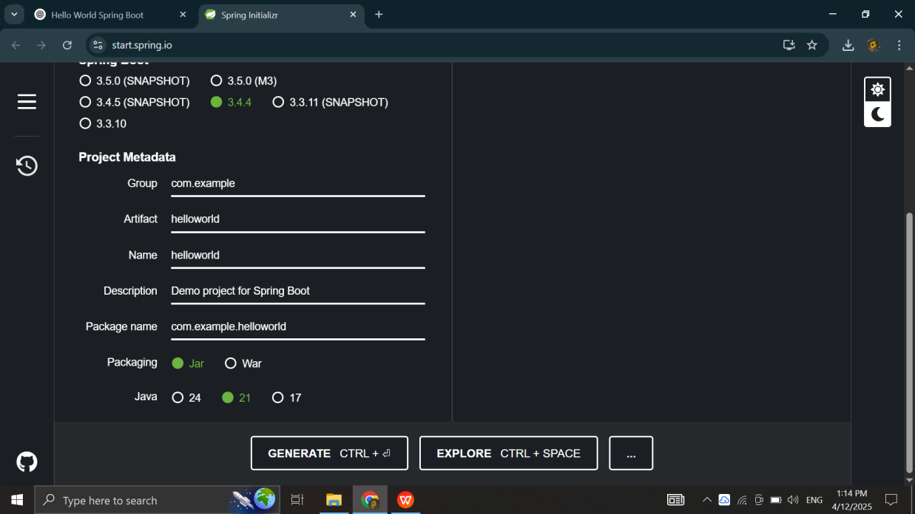

**Step 2: Add Dependencies**

**Make sure Spring Web is added as a dependency. If not, add it manually and regenerate the project.**.

**Step 3: Import Project in Eclipse**

**Extract the downloaded ZIP file and import it in Eclipse IDE as an external Maven project.**

.

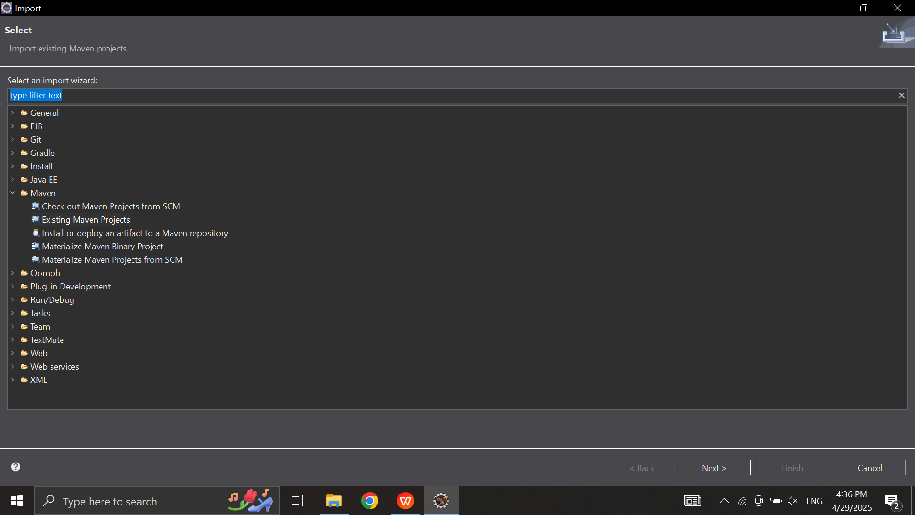

## Step 4: Add Required Dependencies in pom.xml File

<?xml version="1.0" encoding="UTF-8"?>

<project xmlns="http://maven.apache.org/POM/4.0.0"

xmlns:xsi="http://www.w3.org/2001/XMLSchema-instance"

xsi:schemaLocation="http://maven.apache.org/POM/4.0.0

http://maven.apache.org/xsd/maven-4.0.0.xsd">

<modelVersion>4.0.0</modelVersion>

<parent>

<groupId>org.springframework.boot</groupId>

<artifactId>spring-boot-starter-parent</artifactId>

<version>3.4.4</version>

<relativePath/>

</parent>

<groupId>com.example</groupId>

<artifactId>movieticket</artifactId>

<version>0.0.1-SNAPSHOT</version>

<name>movieticket</name>

<description>Hello World Spring Boot Application for Movie Ticket Management System</description>

<properties>

<java.version>17</java.version>

</properties>

<dependencies>

<dependency>

<groupId>org.springframework.boot</groupId>

<artifactId>spring-boot-starter-web</artifactId>

</dependency>

<dependency>

<groupId>org.springframework.boot</groupId>

<artifactId>spring-boot-starter-test</artifactId>

<scope>test</scope>

</dependency>

</dependencies>

<build>

<plugins>

<plugin>

<groupId>org.springframework.boot</groupId>

<artifactId>spring-boot-maven-plugin</artifactId>

</plugin>

</plugins>

</build>

</project>